Design implementation Document:

* The given Rust code creates a basic Blackjack game on a console.
* For user input and randomness, it makes use of the std::io and rand libraries.
* Individual playing cards are represented by the Card struct, which has a value attribute.
* A deck of cards is created by the create_deck function and returned as a Vec.
* The shuffle method from the rand library is used by the shuffle_deck function to shuffle the deck.
* A card can be drawn from the deck using the draw_card function, which also provides the updated deck and the card that was drawn.
* The sum of the card values in a hand is determined using the calculate_sum function.
* In order to display the player's cards and sum, check for blackjack or bust, and request the next move, the game_loop function manages the main game loop.

This code defines a structure to represent individual plating cards.

In this code I had to create a deck of cards, this generates a new Vec card which represents a deck.

This code is to shuffle the deck, basiaclly it takes an existing shuffle and returns a new shuffle deck.

This code is to draw a crad from the deck.

This function calculates the sum of cards in a hand, it takes a slice of card and return their total value.

This section of the code handles the game loop. It also manages the players turn and asking whether to draw new cards and displaying the current one.

This one asks the player to draw new cards .

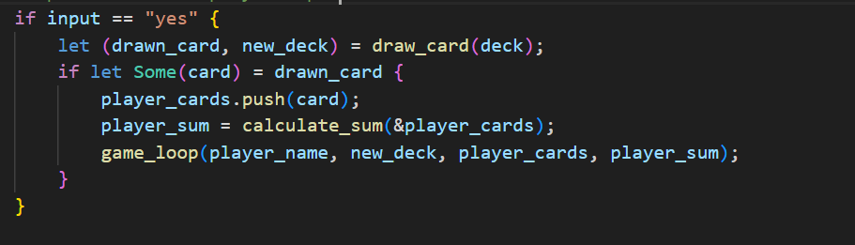

This code processes the players input

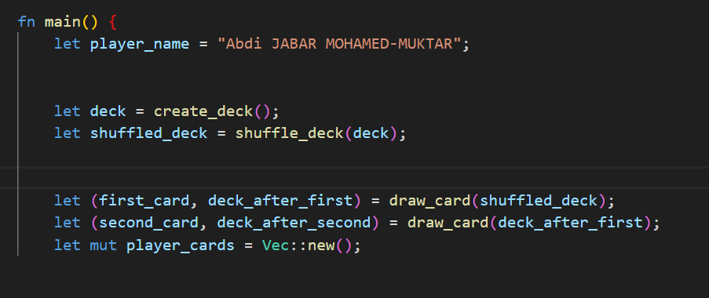

This code defines the main function which is the entre point. It mentiones my name and my id number. Draw card is function that draws a card from the top of the deck, it returns a tuple with drawn card and the update deck.

The code checks if both First card and second card are some values which means that cards were successfully drawn from the deck.